**Northbridge Management Entities and its Flow: -**

**Northbridge Financial Management Entities**

**Federated Insurance**

**Trushield Insurance**

**Northbridge Insurance**

**Northbridge Distribution Channel is further divided as below:-**

**Northbridge Distribution Channel**

**Call Centre-Direct (Cypher)**

**Agent (SBA \ CIS)**

**Broker**

Key Notes:-

* Broker will get business for Northbridge insurance
* Agents will work for Federated insurance
* Customers will reach directly to Trushield thru Call Centers and Cypher agents will sell the policies
* Brokers doesn’t access Duck creek and hence give the customer information to underwriter for further process and receives commission
* Broker will be given with a standard form for the customer to fill in data
* Broker will send the forms filled to the Underwriter through mail
* Agents can directly creates quotes in Duck creek and works for commission

**Northbridge Business Market Areas:-**

Small Business

Mid - Market

**Northbridge**

**Business**

Technical Risk

Specialty Risk

Personal Lines

Other

**Overview of Duck Creek Integration and Overflow:-**

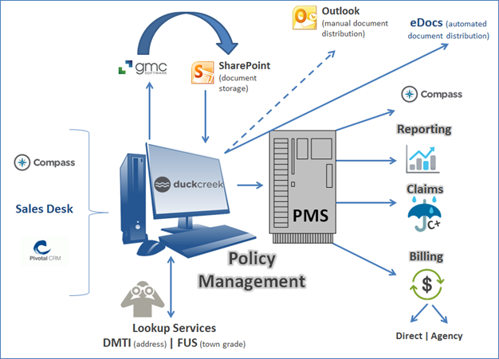

Key Notes:-

* Duck creek integrates with **PMS** (legacy policy management system) whenever there is a policy issued in DC for all the policy information like Quote, Bound, Issue , Endorsement, Renewal etc…
* Duck creek uses ESB (Enterprise Service Bus) which is middleware to connect with **PMS**.
* Duck creek sends policy information in the form of XML and **ESB** converts the XML into a flat file and sends to **PMS**.
* Duck creek also integrates with **GMC** which will be used to generate documents and then the documents will be stored in SharePoint.
* Duck creek can access all the documents from SharePoint.
* Duck creek also integrated with **eDocs** which is an automated document distribution for brokers.
* **DMTI** is a service used by Duck creek for the address standardization.
* Duck creek uses a service called **FUS** (Fire Underwriter Service) when deals with Property \ Home insurance.

**Business work flow from different entities (NBI/Federated/TruShield):-**

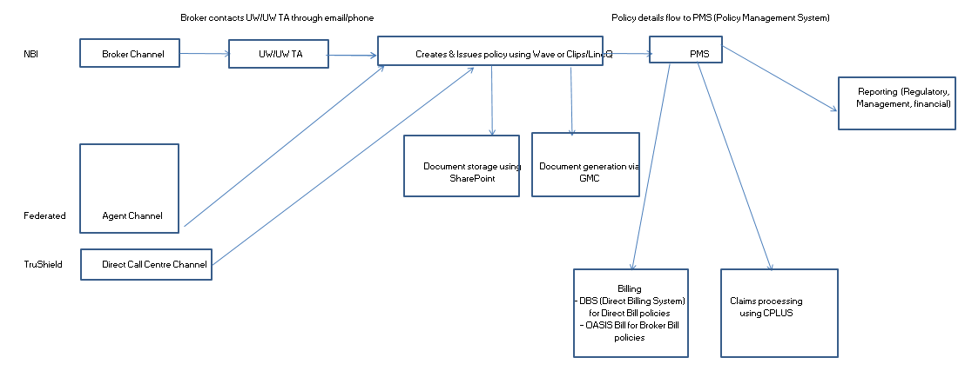

Key Notes of **NBI** business work flow:-

* NBI gets business thru brokers who doesn’t have access to system. Hence brokers provide the customer information to UW/UW TA who can further process the customer details into systems called Wave/Clips/LincQ for policy issuance.
* When policy is issued in Wave/Clips/LincQ then the policy information will be sent to PMS(Policy Management System).
* SharePoint will store all policy related documents from Wave/Clips/LincQ
* GMC is another document storage from Wave/Clips/LincQ
* PMS will further send the policy information to Reporting for Policy management and financial systems and also to billing system and claims system

Key Notes of **Federated** business work flow:-

* Federated gets business thru Agent channel and agents will feed the customer information directly into systems called Wave/Clips/LincQ for policy issuance.
* When policy is issued in Wave/Clips/LincQ then the policy information will be sent to PMS(Policy Management System).
* SharePoint will store all policy related documents from Wave/Clips/LincQ
* GMC is another document storage from Wave/Clips/LincQ.
* PMS will further send the policy information to Reporting for Policy management and financial systems and also to billing system and claims system.

Key Notes of **TruShield** business work flow:-

* TruShield gets business thru customers directly in the mode of an email / call and then the call center team will process their policy information and issue the policy in Wave/Clips/LincQ.
* When policy is issued in Wave/Clips/LincQ then the policy information will be sent to PMS(Policy Management System).
* SharePoint will store all policy related documents from Wave/Clips/LincQ
* GMC is another document storage from Wave/Clips/LincQ
* PMS will further send the policy information to Reporting for Policy management and financial systems and also to billing system and claims system.

**Login Screen**

Application Login Screen where the authorized users login based on the access privileges

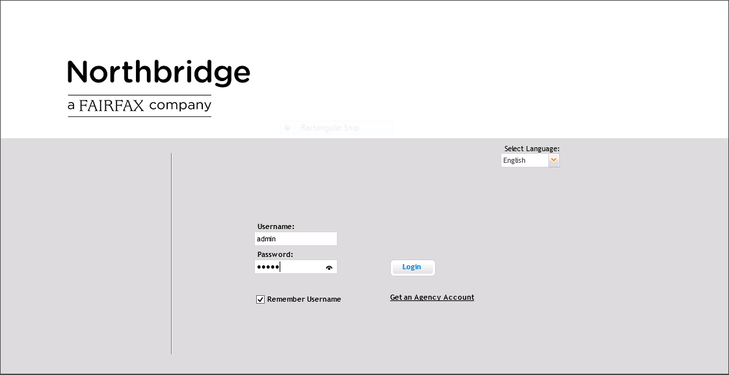

* User’s with different authorities can login thru login screen

**Policy Dashboard**

Gives an overview of the of the recently accessed quotes along with tasks & notifications

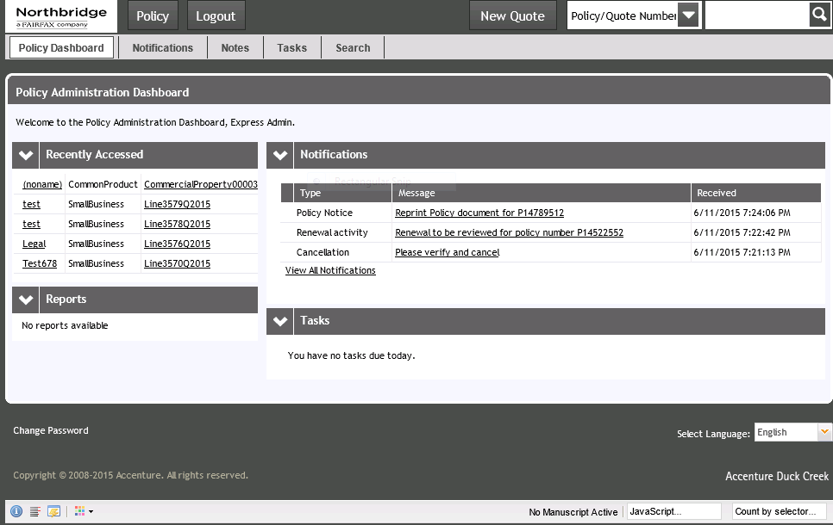

* If user login is success then it will navigate to policy dashboard screen where logged in user will have different section like recently accessed, notifications, reports and tasks to be done.

**New Quote Screen**

Account search

New Quote screen helps the user to start with the quote creation process

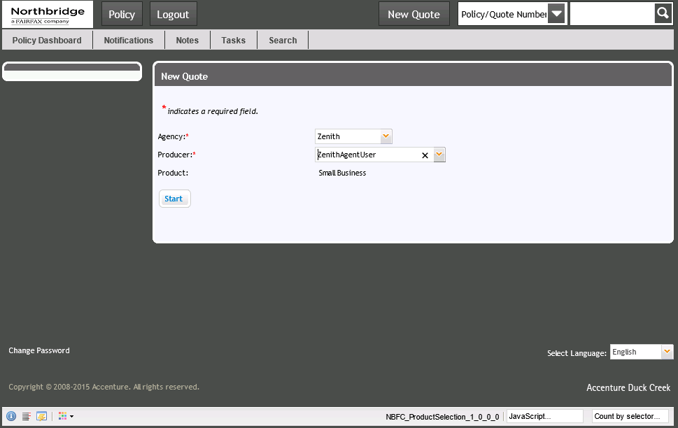

* User will search with the Client name in the given open text box to check whether there is any existing account with any given name.
* If there is an existing Client with the given name user will select the account name for the new quote as one client can have multiple policies.
* If there is no such account existing already in Duck creek, user has to click on **Create New Account** button to proceed with quote which will navigate to Customer screen
* When a new quote is created initially the status is **Quote-New-Pending** with a unique quote number starts with Q and contains 8 digit number

**Ex – Q00176542**

* Northbridge deals business in both English and French language’s based on the selection

**Customer Screen**

Captures all customer related details

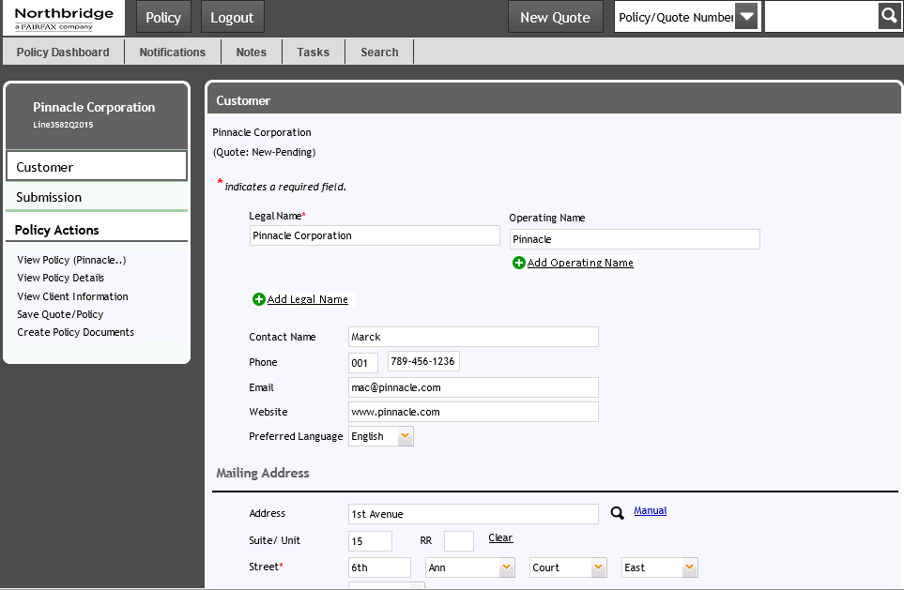

* Legal Name is the Business Official name (Insured name) which can be used in all legal documents to run the business and for which insurance will be given which can be more than one on a policy
* Operating name is the name of a business usual name which can be used in all advertising or publicity of its own business and which will be much known to customers.
* Contact name is the person to whom an insurance company contacts first then any other person in any time with regard to the policy.
* Mailing address is the insured mailing address to which policy documents or any other notice will be sent to insured from an insurance company.
* User will select the IBC codes in the TYPE drop down based on the customer requirement.
* Based on the user logged into the system Menu bar will be different and Integration Failure tab is visible only for System Admin.
* System Admin is from NBFC level and there is no system admin at legal entity or Management entity level.
* Also based on user roles certain screen will be appear.
* Phone number is mandatory for direct channel (Trushield) business and optional for other business.

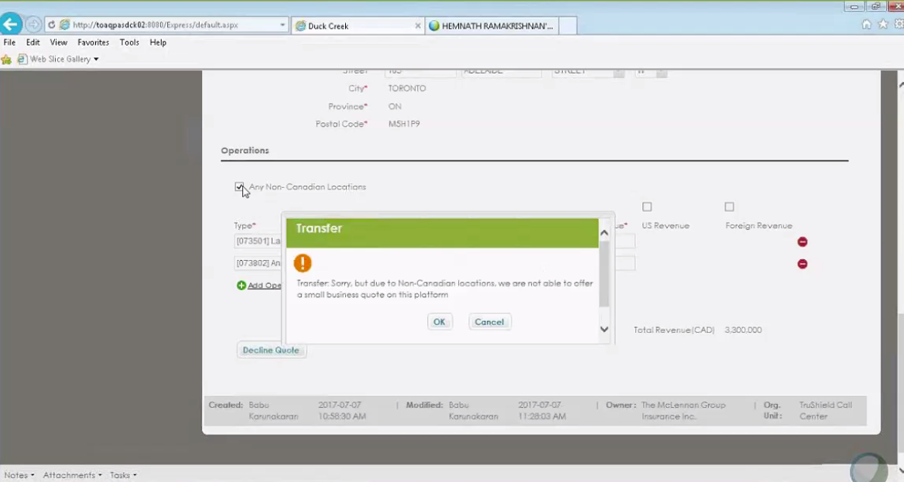

* IBC codes are 3 types 1.Fast flow 2.Exceptions and 3.Transfer
* Fast flow IBC codes don’t have exceptions so that no need of any approvals.
* Exception IBC codes will have exceptions which will be either approved or declined.

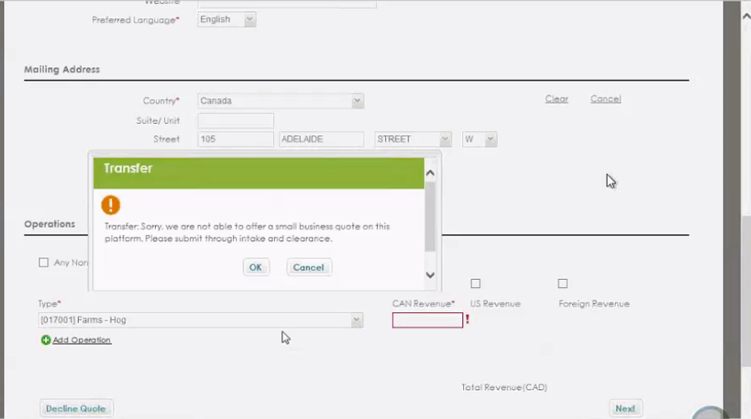

* Transferred IBC codes will be transferred for reasons like they may not fit for small business and needs to be transferred to middle market which can be issued thru Clips(Legacy system from scratch)

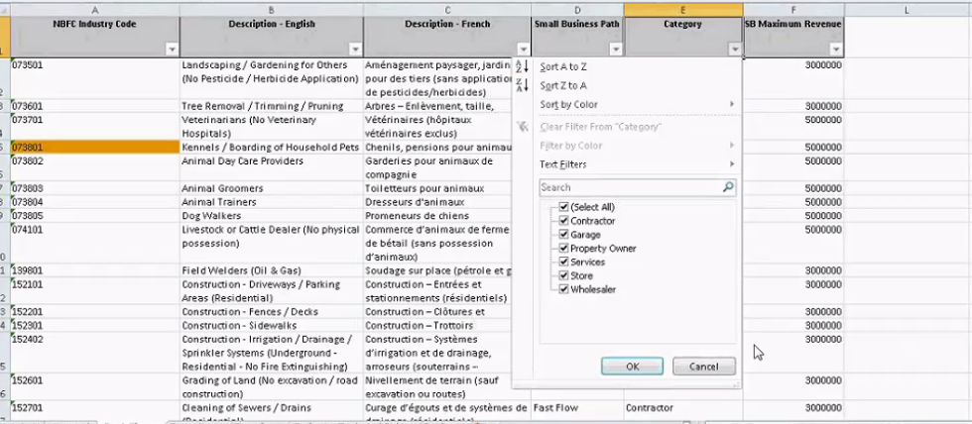

* IBC codes grouped in as Manufacturing \ construction \ Farms \ Garage \ Store \ Property owner \ Wholesaler \ Services

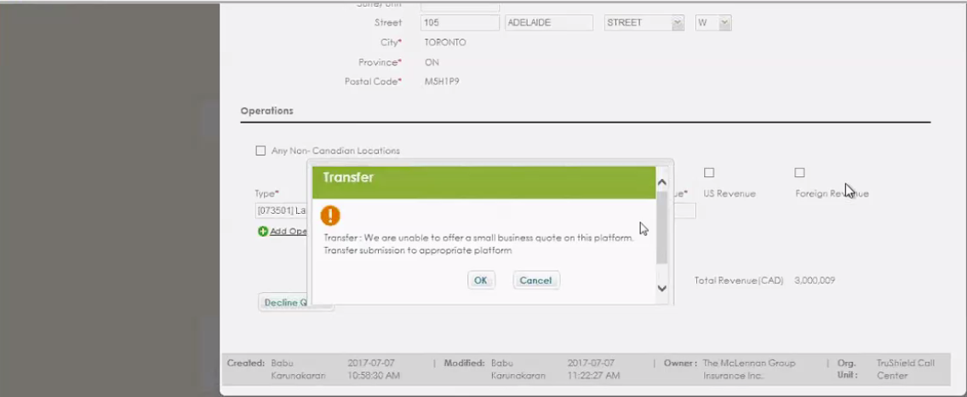

* For contractor’s IBC code CAN revenue is max 3,000,000 if it is more than that system will trigger the transfer condition.
* If Any Non-Canadian location is selected Duck creek currently not offering and hence transfer condition will be triggered.

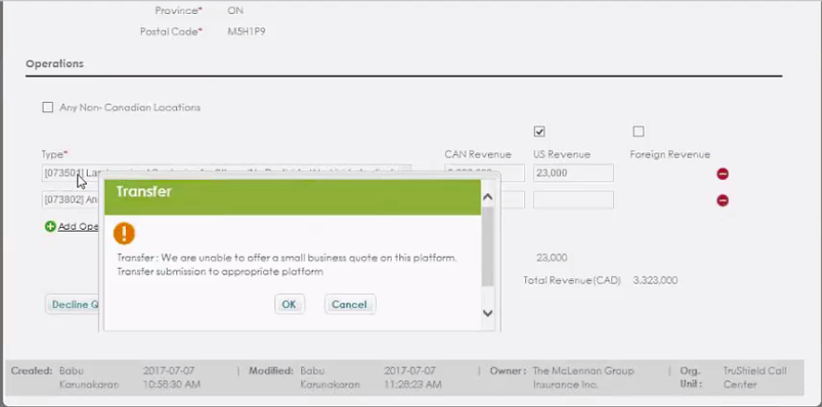

* US revenue and foreign revenue check boxes will be selected if customer has sales in US and Foreign.
* Based on IBC code, if it is not allowed for US or foreign revenue then as showing up above Transfer condition will be triggered.
* If it is transferred there is no further action from duck creek side.

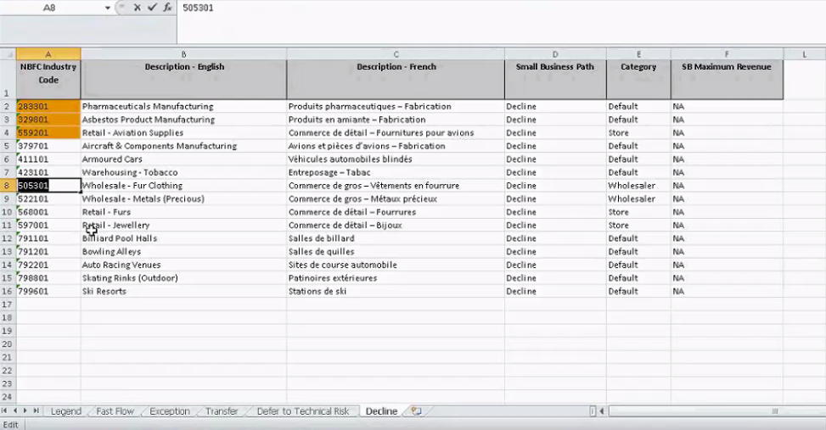

Decline IBC codes

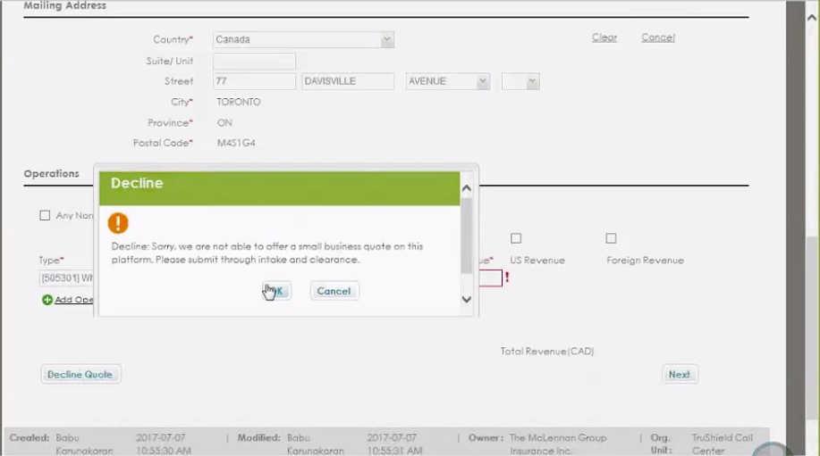

Like transfer message we have Decline message too based on the IBC code selection.

**Submission Screen**

All the submission related data are captured – details regarding new business opportunity

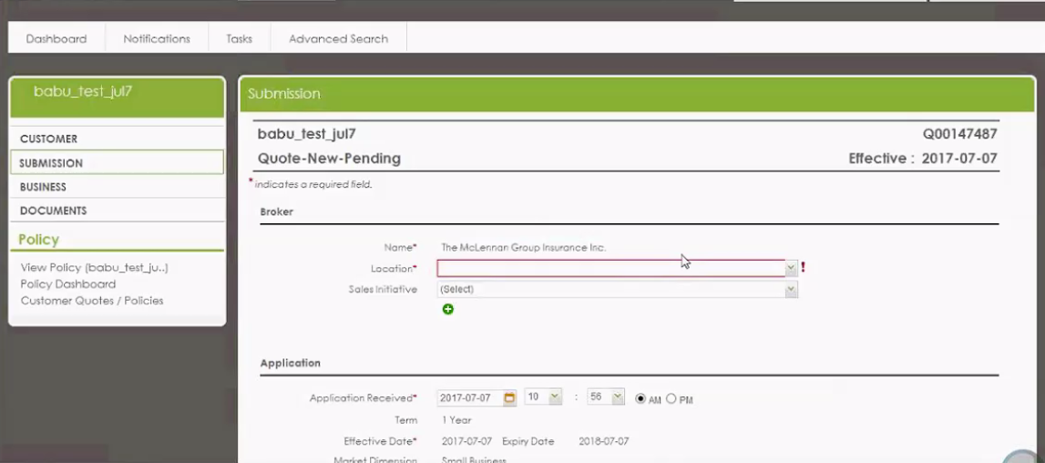

For Trushield there is only one producer who is Mclennan Group Ins. Inc

Trushield does business thru McLennan Group Insurance Inc. produce r and there is no other producer for Trushield.

Sales Initiative is the category under which the broker belongs to.

Trushield falls under NGIC(Northbridge General Insurance Company) and for Federated falls under Federated Insurance Company.

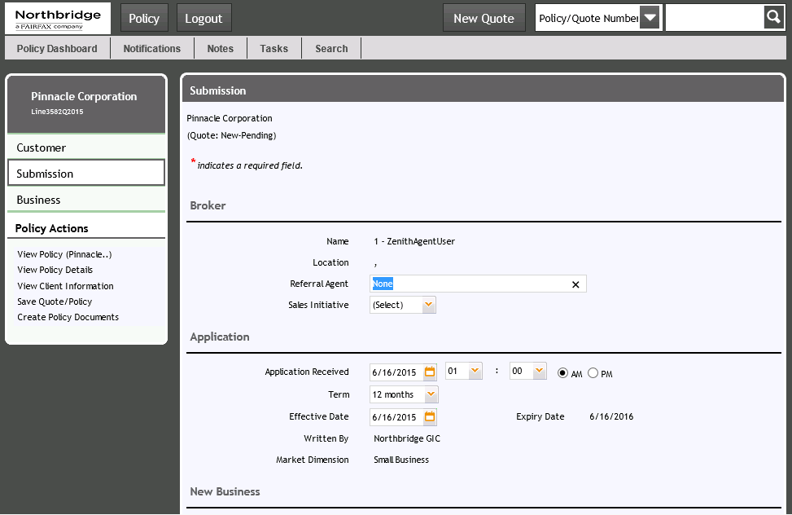

* Submission screen section is depends on who logged into system. If Underwriter logins the submission screen will show as broker screen section and if Agent logins the section will be displayed as Agent.
* If an underwriter logins as TruShield, then the name of the broker is “McLean Insurance Inc”.
* User will enter the basic details of the customer policy like application received date, effective date of the policy, term of the policy , who writes the policy (NB entity) and what is the market dimension like Small Business or Middle Market and click on next will take the user to Business screen.

**Business Screen**

All business related inputs are captured

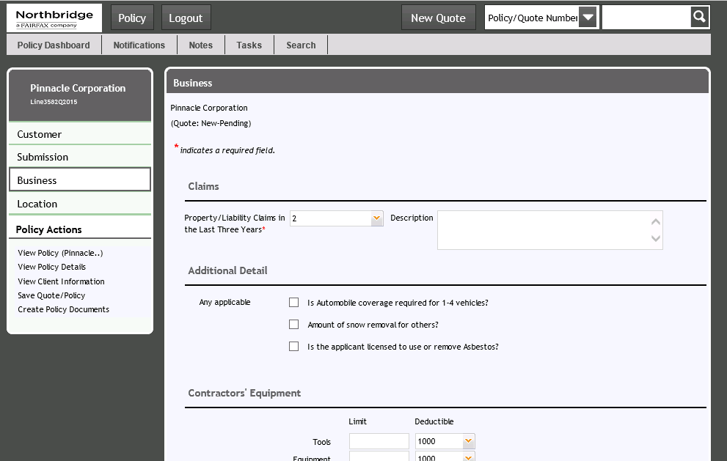

* Business screen will capture Claims related data of the customer on property / liability and any other additional details with respect to insured business
* On this screen user will select the Limit and deductible for each of the coverage that the insured wants for each Line of business area
* Based on the IBC (Industry business code) selection, different coverage’s will be displayed on each line of business
* Each IBC code has its own limit and if the limit is more than the predefined limit it should be transferred.
* Based on business requirement rules (BR’s), exceptions will be triggered on screen where Agent / Underwriter should approve or Decline.
* Revenues will be entered in Canadian, US and Foreign revenue and total revenue should be in acceptable limit

**Location Screen**

Location related information are captured

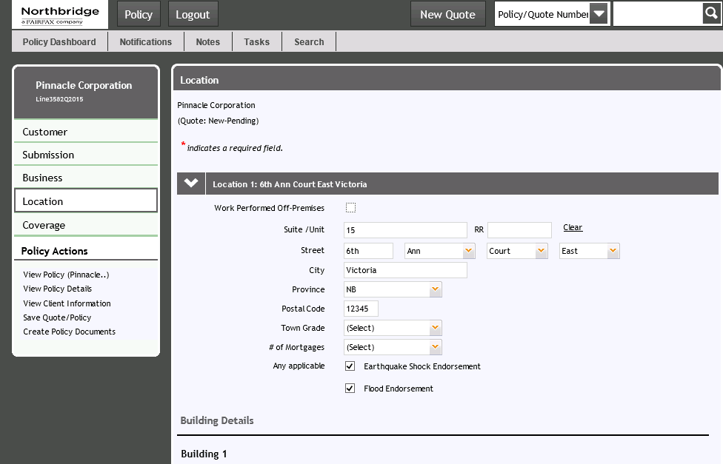

* If Non-Canadian location is selected then the quote will be declined.
* Some coverage’s will be added by default based on the postal code and such type of coverage’s is location level coverage’s.
* Maximum buildings are added at a single location is 10.
* Max CAP for a location is 5 million and for all location the total should not be more than 10 million and if exceeds the quote should be transferred.
* For Small business area the total revenue should not be 3 million.
* For any business which doesn’t have physical location we can select the option “Work performed off premises”. Ex – Online business.
* When agent works with basic information of a customer and creates quote, it will go to **Missing Information** state when agent tries to save the quote. Where the quote further edited and added with required information.
* Maximum mortgagees we can have is 3

**Coverage Screen**

Selection of required coverage’s

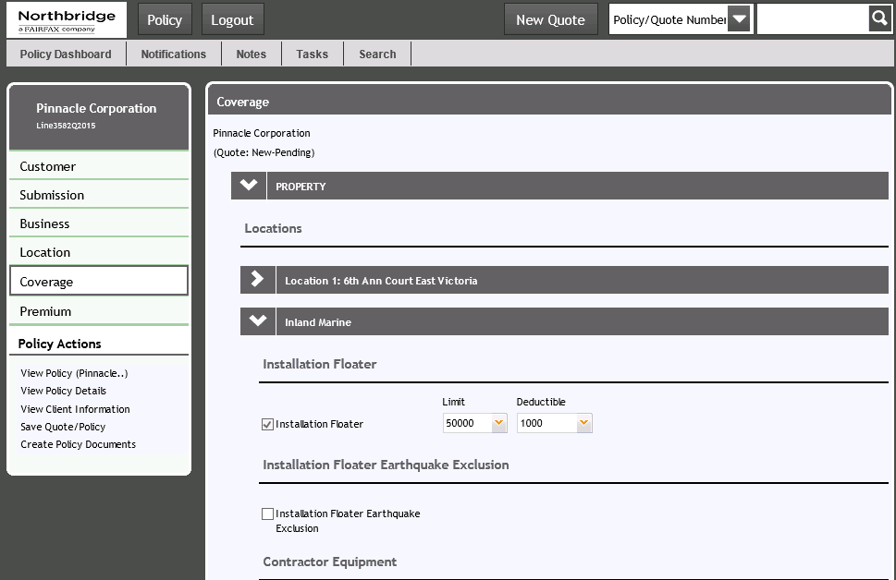

* This is the coverage’s screen where user has to enter the Limit and deductible for each of the coverage
* Based on the IBS codes selected in location screen the list of coverage’s will be displayed in Coverage’s screen
* Flow will be -> Property -> Locations -> Coverage’s
* The screen shows us Property and Liability and under Property we have commercial property, inland marine, contractor equipment and in Liability we have general liability, Professional liability, cyber risk and so on.

**Premium Screen**

Display of calculated premium as per the selection of coverage’s

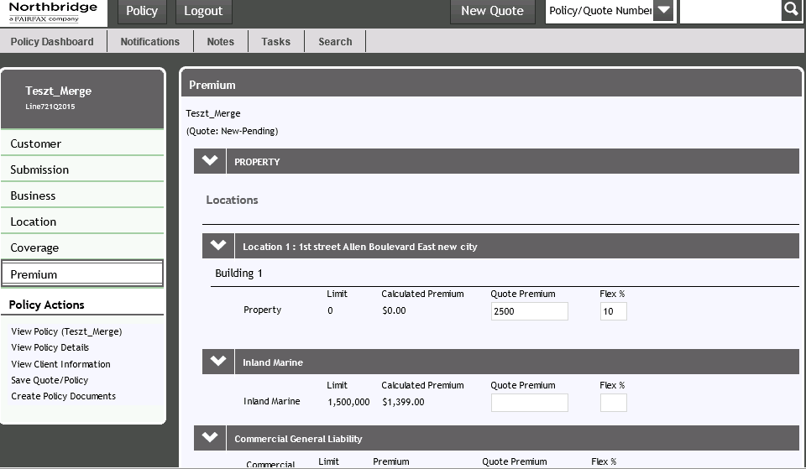

* The premium details will be displayed on this screen for each coverage.
* Northbridge offers two types of bill payment 1.Direct bill and 2.Broker bill.
* There are 3 types of bill payment methods
  + Billing (direct billing)
  + Credit card Payment
  + EFT
* Customer has the option of selecting payment installments as below
  + 1 – Premium will be paid in 1 installments
  + 2 – Premium will be paid in 2 installments
  + 3 - Premium will be paid in 3 installments
  + 4 - Premium will be paid in 4 installments
  + Monthly - Premium will be paid in 12 installments

**Tasks –**

* Tasks can be created manually and automatically by system.
* User will create tasks and assigns to the corresponding UW/UW TA for approval
* Automatic tasks are created by system and assigned to UW/UWTA for approval
* Tasks can be created for many reasons. For an example if agent doesn’t have access to proceed with some business requirements and then he creates a task manually and assigns to the UW for approval
* A task can be edited/ completed / declined / deleted.
* A task can be reassigned to some other queue.
* An underwriter can pick any tasks which are in his/her queue from the available tasks

**Transactions** –

Below are the different policy transactions with status

|  |  |  |
| --- | --- | --- |
| Policy Phase | Status | Stage |
| Quote created | Quote - New – Pending | Quote |
| Quote required info missed | Quote – New – Missing info |
| Quote Does not fit the SB definition | Quote - New - Transferred |
| No action taken >90 days when Quote - New – Pending | Quote - New - Expired |
| If any tasks created on Quote - New – Pending | Quote - New - Referred |
| If UW is not ok with the quote | Quote - New - Declined |
| When exceptions are approved when Quote - New – Pending | Quote - New - Approved |
| When user clicks on Quote button | Quoted - New - Pending |
| When user clicks on Not bound button | Quoted - New - Not Bound |
| User clicks on bind button when Quoted - New - Pending | Bound - New - Pending | Bound |
| If any exceptions on Bound - New - Pending | Bound - New - Referred |
| If any exceptions on Bound - New - Pending are not ok | Bound - New - Declined |
| If exceptions are approved when Bound - New - Pending | Bound - New - Approved |
| User clicks on Book button when Bound - New - Pending | Booked - New - Pending | Booked |
| If any exceptions on Booked - New - Pending | Booked - New - Referred |
| If any exceptions on Booked - New - Pending are not ok | Booked - New - Declined |
| If exceptions are approed when Booked - New - Pending | Booked - New - Approved |
| If user clicks issue button when Bound - New - Pending | Inforce - New - Committed | NB |
| If user clicks issue button when Booked - New - Approved | Inforce - New - Committed |
| User performs endorsement on Inforce - New - Committed | Inforce - Endorse - Pending | Endorsement |
| User click on quote when Inforce - Endorse - Pending | Inforce - Endorse - Quoted |
| If any exceptions on Inforce - Endorse - Pending | Inforce - Endorse - Referred |
| If UW apporves the exceptions when Inforce - Endorse - Referred | Inforce - Endorse - Approved |
| If any exceptions on Inforce - Endorse - Pending are not ok | Inforce - Endorse - Declined |
| User clicks on Not bound button when Inforce - Endorse - Quoted | Inforce - Endorse - Not Bound |
| If user clicks on Issue button when Inforce - Endorse - Quoted | Inforce - Endorse - Committed |
| If user clicks on Issue button when Inforce - Endorse - Pending | Inforce - Endorse - Committed |
| If user clicks on Issue button when Inforce - Endorse - Approved | Inforce - Endorse - Committed |
| User performs Renewal on Inforce - New - Committed | Inforce - Renew - Pending | Renewal |
| If any exceptions on Inforce - Renew - Pending | Inforce - Renew - Referred |
| If UW apporves the exceptions when Inforce - Renew - Referred | Inforce - Renew - Approved |
| If any exceptions on Inforce - Renew - Pending are not ok | Inforce - Renew - Declined |
| If user clicks on Issue button when Inforce - Renew - Pending | Inforce - Endorse - Committed |
| If user clicks on Issue button when Inforce - Renew - Approved | Inforce - Renew - Committed |
| User performs Non Renewal on Inforce - New - Committed | Inforce - Non Renew - Pending | Non Renew |
| If user clicks on Non Renew button when Inforce - Non Renew - Pending | Non Renewed – Non Renew - Committed |
| If user clicks on Rescind button when Non Renewed – Non Renew - Committed | Inforce – Rescind Non Renew - Pending |
| If user clicks on issue button when Inforce – Rescind Non Renew - Pending | Inforce - Rescind Non Renew - Committed |
| User performs Cancel on Inforce - New - Committed | Inforce - Cancel - Pending | Cancellation |
| If any exceptions on Inforce - Cancel - Pending | Inforce - Cancel - Referred |
| If UW apporves the exceptions when Inforce - Cancel - Referred | Inforce- Cancel-Approved |
| If user clicks on Cancel button when Inforce- Cancel-Approved | Cancelled - Cancel - Committed |
| If user clicks on Cancel button when Inforce - Cancel - Pending | Cancelled - Cancel - Committed |
| If user clicks on Reinstate button when Cancelled - Cancel - Committed | Inforce - Reinstate - Committed | Reinstate |
| If user clicks on Reissue button when Cancelled - Cancel - Committed | Cancelled - Reissue - Pending | Reissue |
| If user clicks on Issue button when Cancelled - Reissue - Pending | Inforce - Reissue - Committed |
| If user clicks on Decline button when Cancelled - Reissue - Pending | Cancelled - Reissue - Declined |
| If user clicks on Abort button when Cancelled - Reissue - Pending | Cancelled - Cancel - Committed | Cancellation |

**Rating:-**

Rating is one of the typical validations in Policy admin testing for all policy transactions. Rating validation will be carried with the help of rate books which will be provided by Northbridge business actuaries.

Rating validation Approach –

Rate books are used to enter the same policy data that is created and rated already from duck creek application. A sample rate book looks like as below.

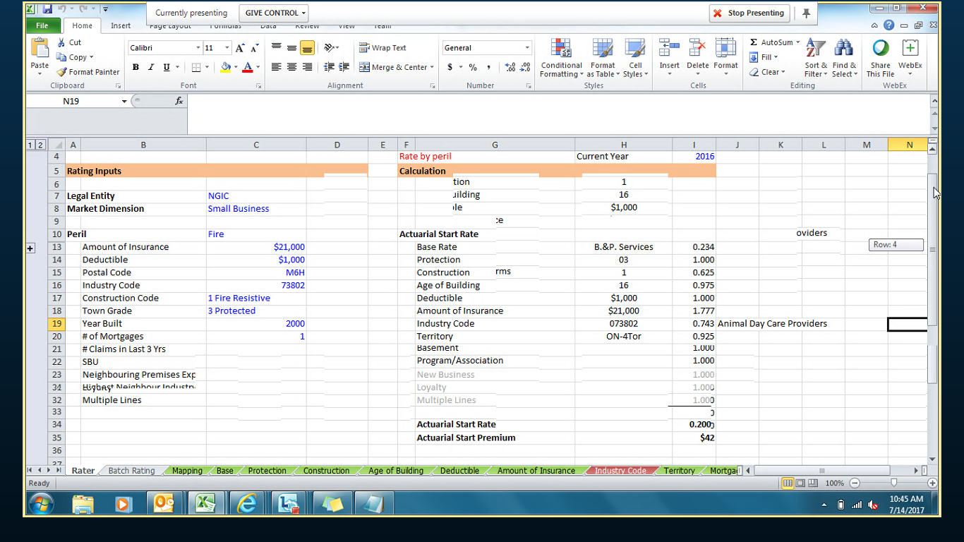

The RATER tab is the place where user enters the text which is in blue (Amount of Insurance , Deductible , Postal code , Industry code, Construction code, Town grade, Year built and # of Mortgages if it is a building) needs to be entered from Premium screen of the duck creek application.

The rate book is completely driven by macros \ Vlookup and hence when user enters the data the rate book calculates premium automatically and displayed at Actuarial Start Premium row as shown above with red colored box.

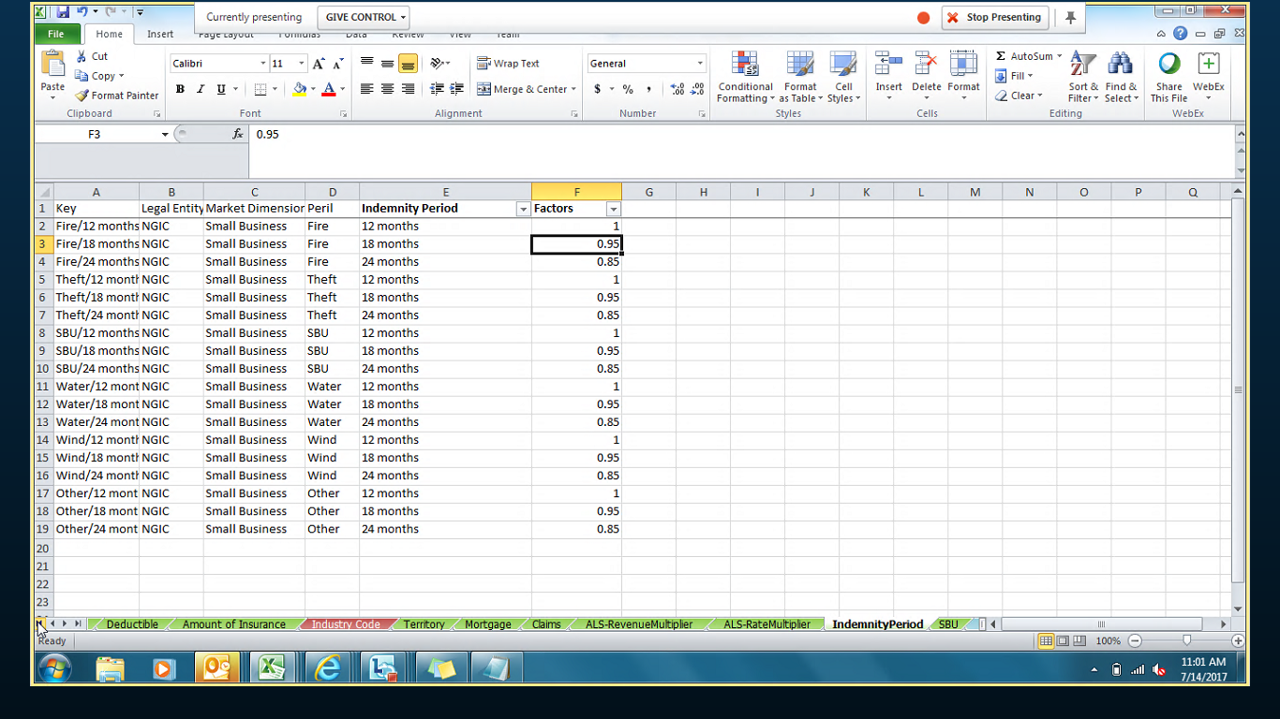

Rate book contains several tabs in which rating related factors which are required will be stored and when user enter the policy info in RATER tab in each of the row the corresponding value / factor will be fetched from other tabs like Batch Rating, Mapping, Base, Protection, Construction, Age of building, Deductible, Amount of Insurance, Industry code, Territory etc… as highlighted in the above screen shot.

Example – Building Rating Premium comparison between DC UI and Rate book

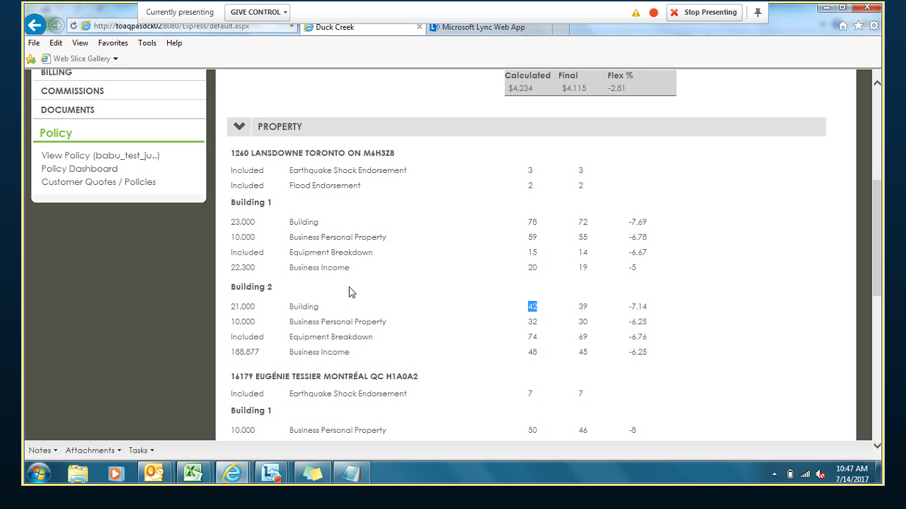

For Building 2 the premium generated in DC is $42.



For the same building, details are entered in rate book and premium is matching as $42.

Example for Business Personal Property –

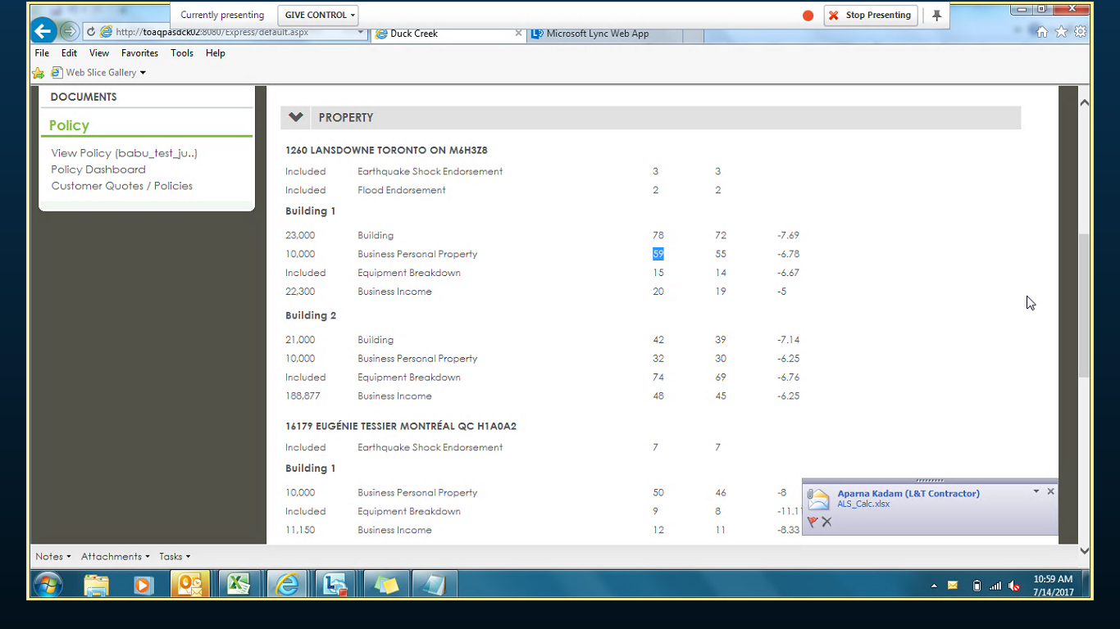

Premium is $59 on DC UI

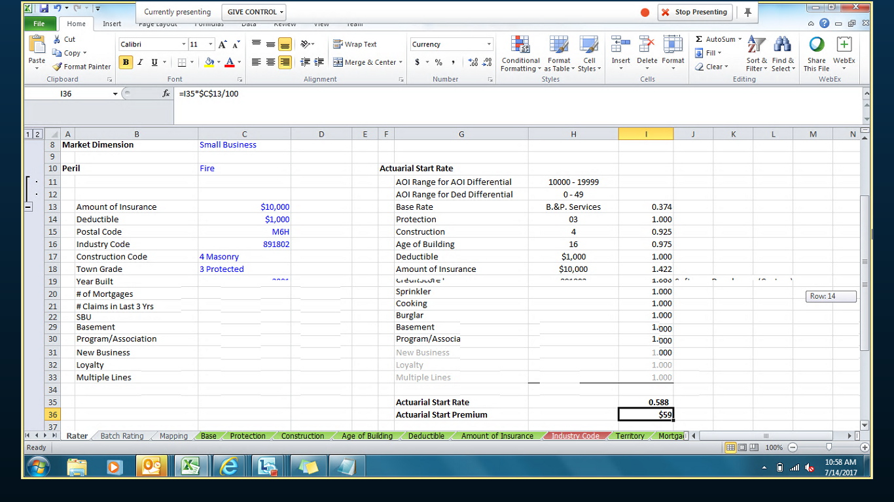

Premium Is matching with Rate book as $59.

Equipment break down rater looks like below

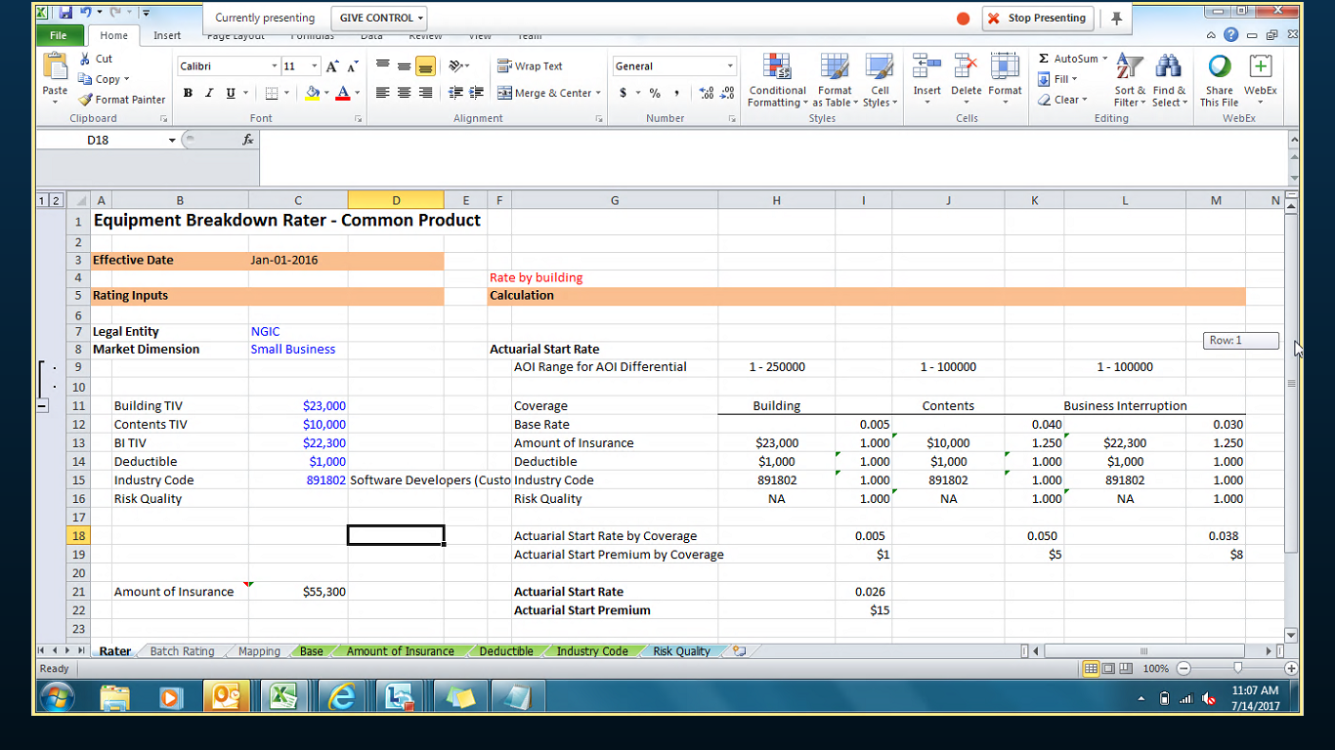

Examples of Rater books:-

1. Building

2. Business Personal Property

3. Equipment breakdown

4. Business Income

5. Earthquake rater

6. Flood rater

7. Crime – Employee Dishonesty

8. Cyber Risk

9. CGL

10. Aggregate endorsement rater

When more than one IBC is applicable for rating than as shown below different IBC codes will be entered to generate the premium.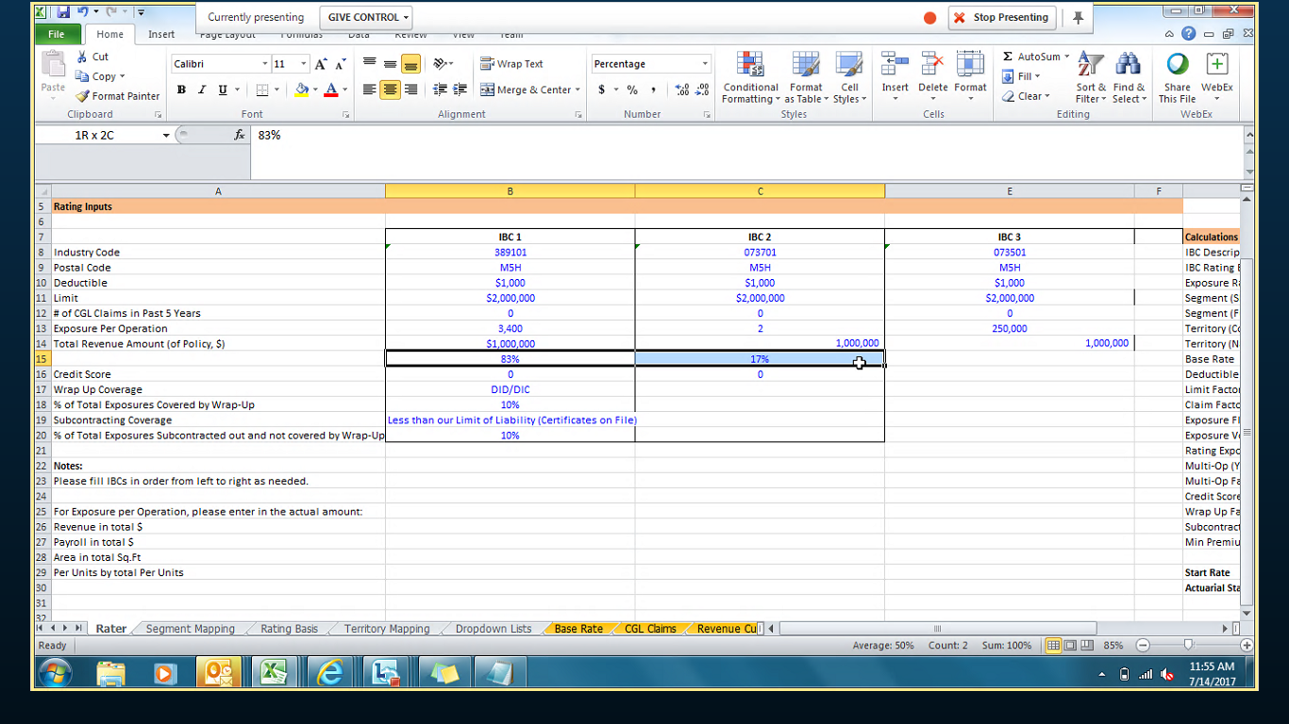

For IBC code exposure% = exposure operation/Total revenue income * 100 and sum of all the IBC(Industry business code) codes percentage should be equal to 100.

**DC Support Viewer (XML Viewer):-**

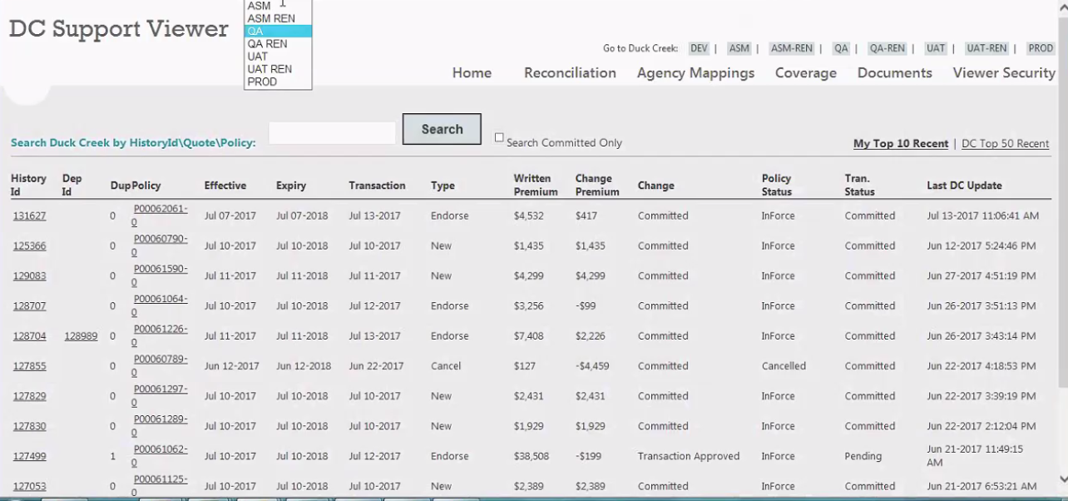

DC XML viewer has different environments as given below.

* DEV
* ASM
* ASM REN
* QA
* QA REN
* UAT
* UAT REN
* PROD

Mainly DC XML viewer is used internally in the below scenarios

User wants to see and verify all the policy transactions that are performed on a given policy if, any new requirement is implemented. Enter the policy number and click on search button to see all the transactions on the policy will be displayed and each transaction has a unique history id and if, user wants to see a particular transaction details of a policy has to click on the history id (which is a link) and that displays the transaction details.

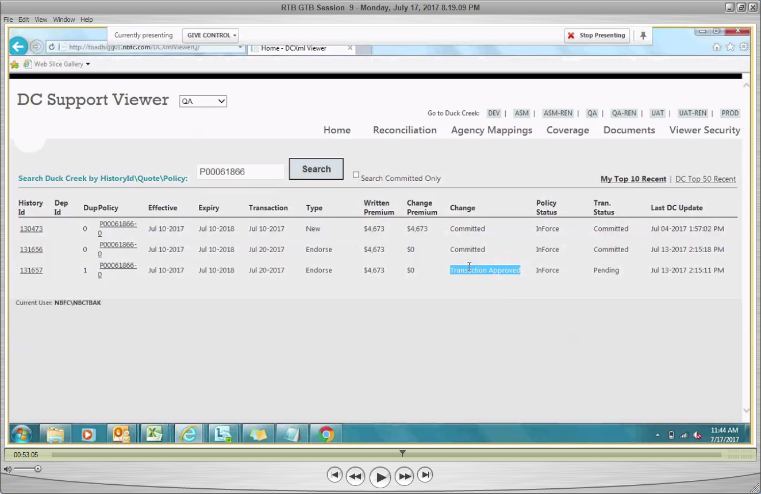

Policy# - P00061866 has entered and clicked on search.

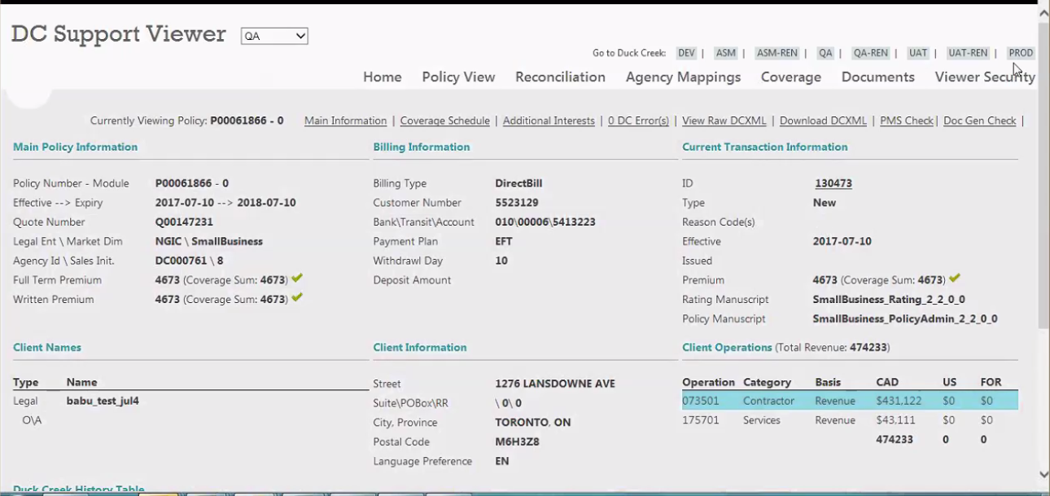

User can check the policy information in different sections like Main Policy Information, Billing Information, Current Transaction Information, Client Names, Client Information and Client Operations.

As highlighted in red color, If the Full term premium and Written premium are matching then a tick (√) with green color will be displayed. If both premiums are not matching then a tick (X) with red color will be displayed.

The testing instances are below –

GTB implements a new coverage with some rates and user has to verify the premiums.

The actual information of a policy from XML which triggers in duck creek will be updated in DC XML viewer. The policy information need not be reached to PMS in order to see the policy data in XML viewer.

As and when we create a policy in Duck creek the policy flow will be started in DC XML viewer so that user can verify the policy information as required.

* User creates a quote in duck creek, the quote can be seen in pending status in DC XML viewer
* 2.User has quoted the policy in duck creek, the quoted status can be seen in DC XML
* 3.User has issued the policy in DC, In-force status can be seen in DC XML viewer
* 4. User has performed subsequent transactions on New Business, the subsequent transactions status can be seen in DC XML viewer.

By Oct 2017, we will be having Rating Manuscript version 2.3 as it 2.2 now.

DC XML viewer is will not updated on daily basis and hence if any issue that needs to be communicated to Dev asking them to update.



Different tabs for policy data like Coverage’s / additional interests/

Click on **Coverge Schedule** will be displayed the coverage’s on the policy

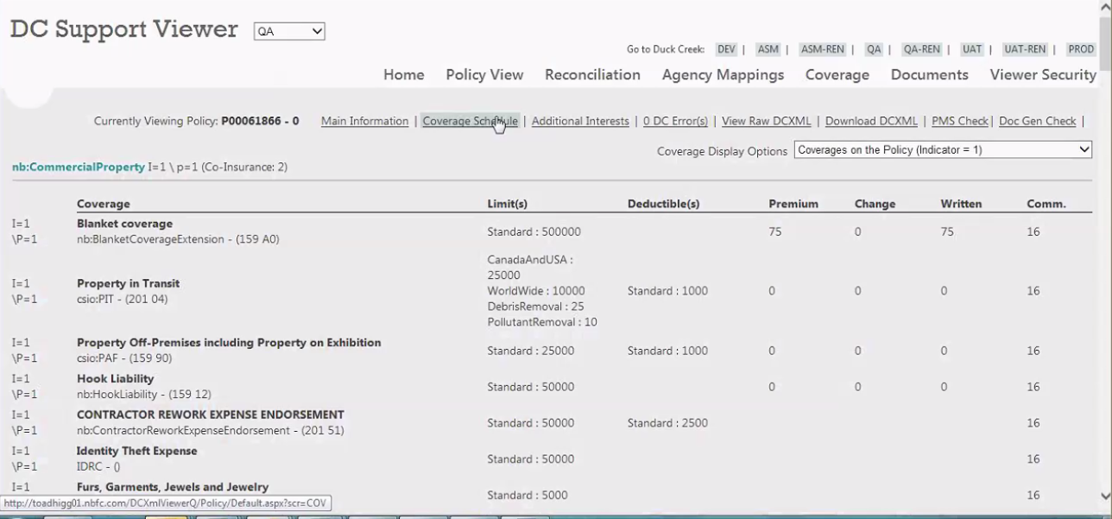

While working on a quote / policy due to an integration failure user cannot proceed.

Ex. During endorsement quoting an error triggers (reason could be in PMS a batch is running due to which integration service is down with duck creek)

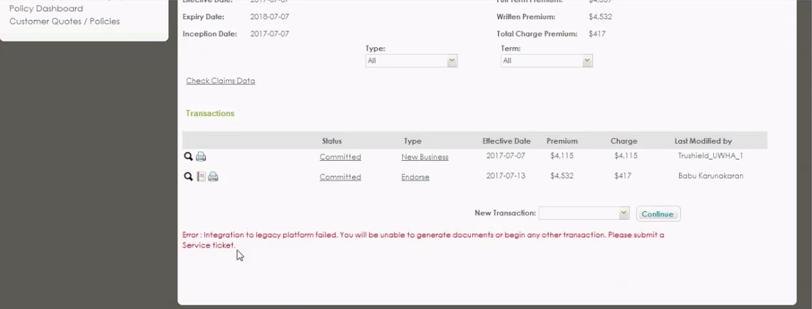

In DC we had some error. Reason can be debug in DC XML viewer as below

Enter the policy and click on search button give the below screen

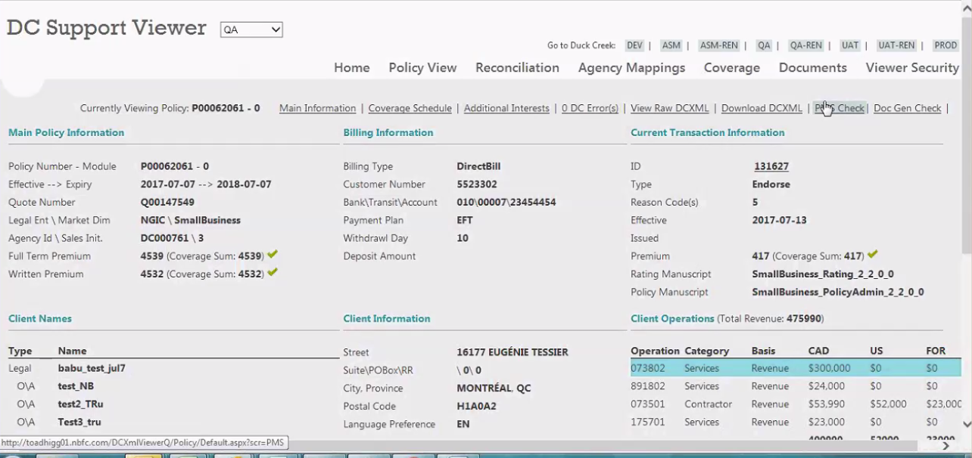

Then click on PMS check and the screen will be as below

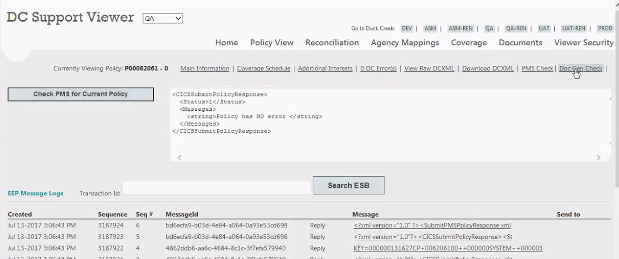

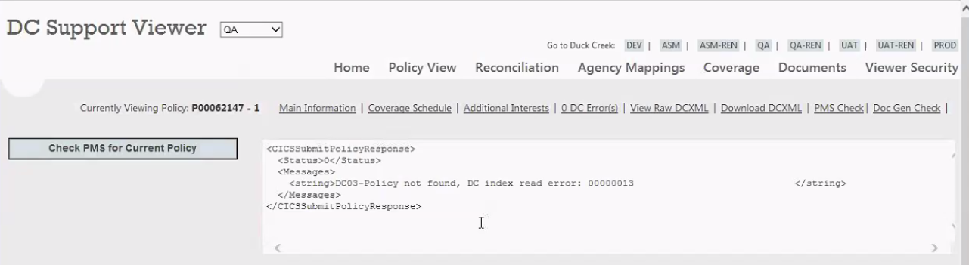

Reasons can be as

1. Batch is running in PMS side
2. There is no mapping done from PMS side for any on the field
3. If any service is down / closed
4. DC Agent id is not mapped in PMS
5. Can’t commit endorsement on the same policy on the same day
6. XML generation issue due to schema

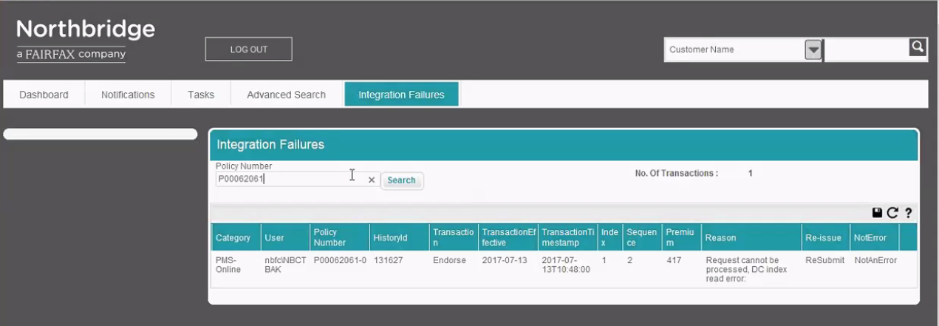

If user logins as an admin in Duck creek, can see the integration failures on a policy as shown above.

Few other reasons are

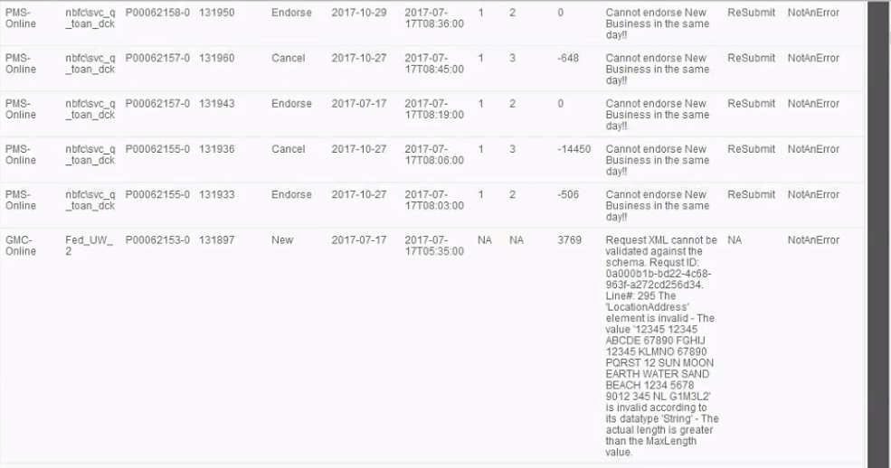

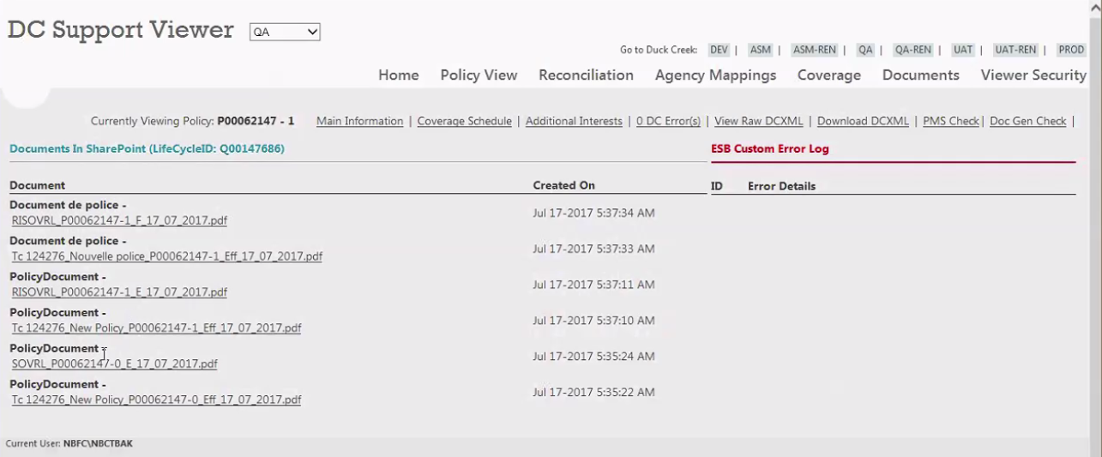

Click on Doc Gen Check link and then on the pdf file as shown above for policy related documents.



Click on Download DCXML link to download the Policy XML

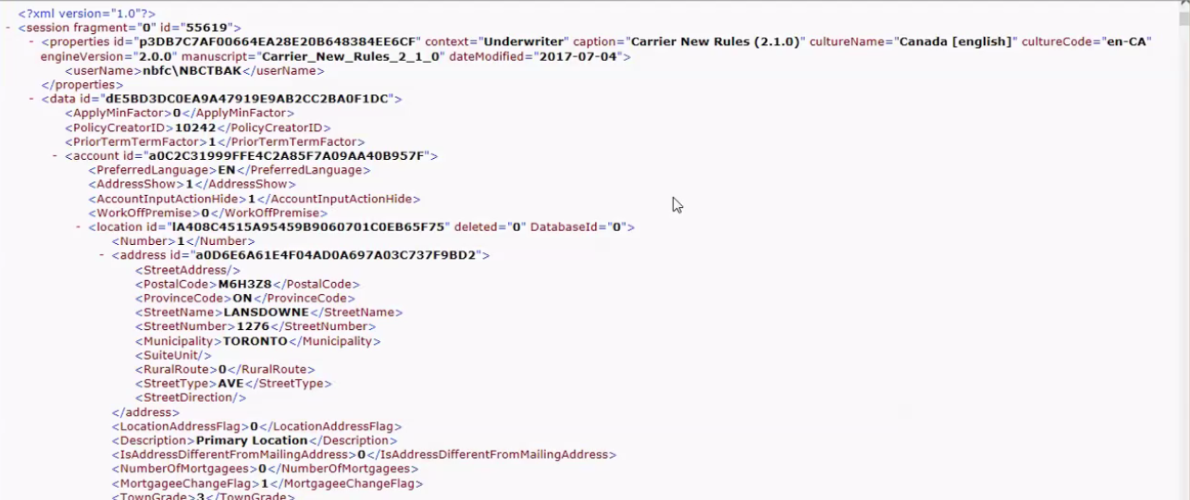

The date of XML should match with the DC XML viewer.

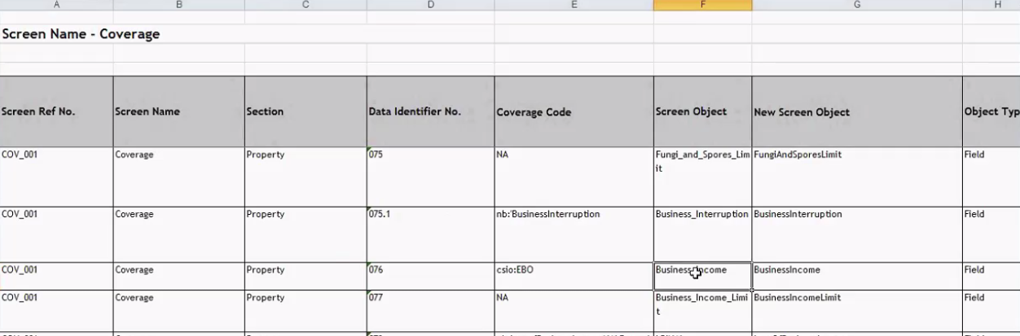

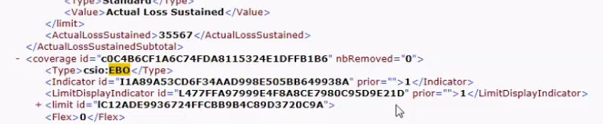

Ex . Coverage code EBO for Business Interruption and for any coverage if Indicator is 1 as highlighted above is passed thru XML that means its checked.

Always search with the coverage code instead of coverage name.

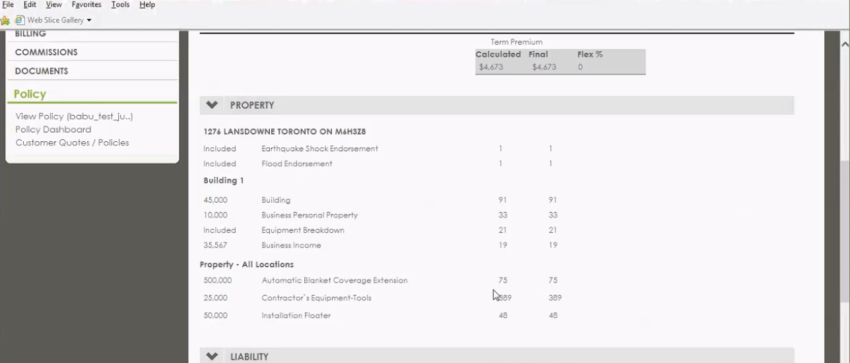

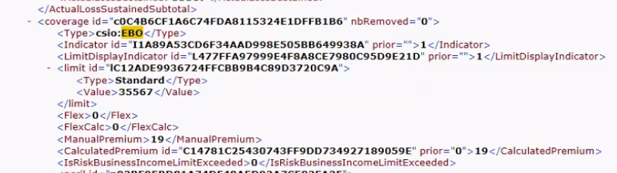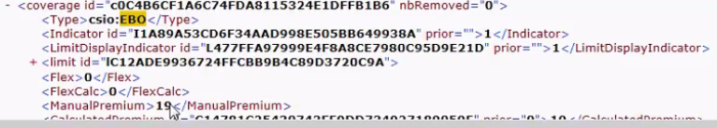

Limit and Premium is matching on DC UI and Premium for Business Income coverage.

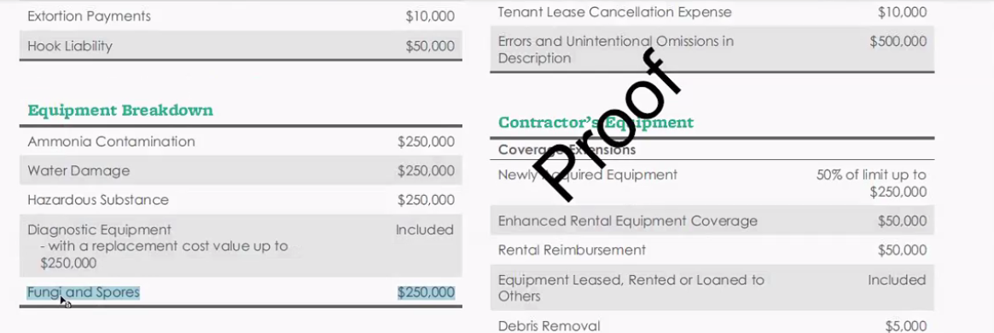

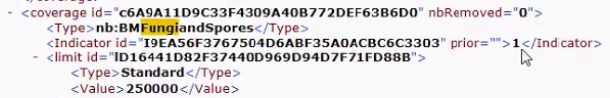

Some coverage’s are not checked in DC UI but they will be passed thru XML which are default as highlighted above.

Ex. Hazardous Substance and Fungi and Spores